https://www.youtube.com/watch?v=0-YMPk4kdTo
Datadog is an infrastructure monitoring service ,.

It enables devops team to keep tab about dynamic cloud environments
Easy to visualize health of your infrastructure
At high level or at location , application or service level

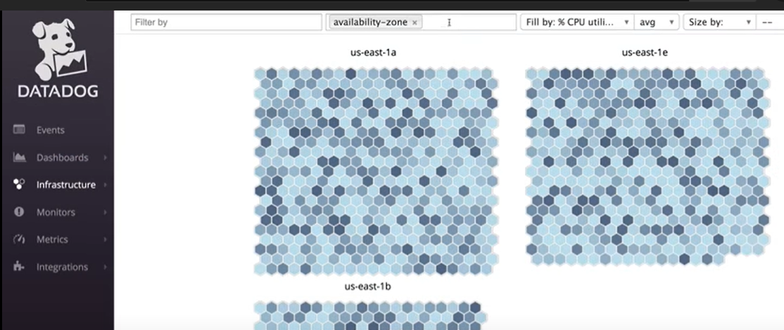

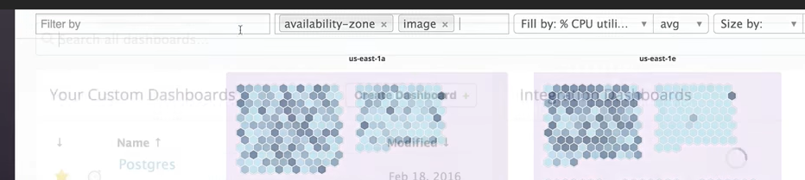

It can be viewed at granular level at server level

It can be setup with Datadog Agent , API , 120+ Integrations

Datadog agent can run on cloud and hybrid infrastructure
It can be installed on all operating systems

Agent to collect metrics from services and tools running on a host

We can send metrics to Datadog with APIs
DogStatsD accepts custom application metrics points over UDP

We can also used libraries which are available in all languages

Datadog offers preconfigured dashboards
With AWS integration users will see out of the box configuration metrics , dashboards

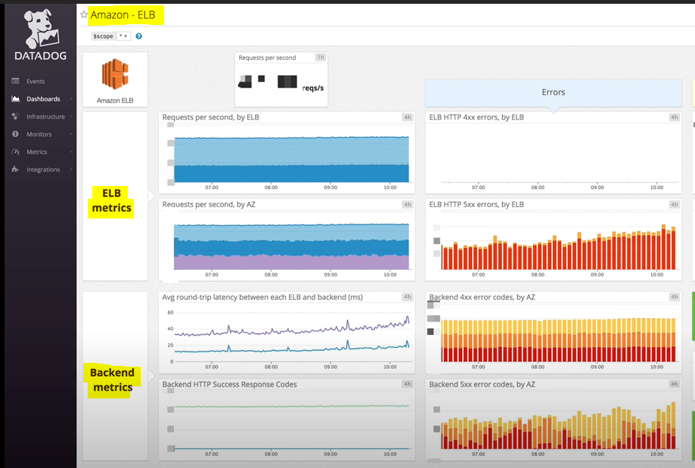

Custom dashboards

There are two types of board’s , TimeBoard and ScreenBoard

TimeBoard – Great for troubleshooting and correlation
ScreenBoard – Great for status boards and sharing information

Alerted with critical data with monitors

Kafka deployments often rely on additional software packages not included in the Kafka codebase itself—in particular, Apache ZooKeeper. A comprehensive monitoring implementation includes all the layers of your deployment so you have visibility into your Kafka cluster and your ZooKeeper ensemble, as well as your producer and consumer applications and the hosts that run them all. To implement ongoing, meaningful monitoring, you will need a platform where you can collect and analyze your Kafka metrics, logs, and distributed request traces alongside monitoring data from the rest of your infrastructure.

